Lab 6 Report

Willow Westbrook
Loyola Marymount University
BSAN-6070-02: Intro to Machine Learning

Contact Me
wwestbro@lion.lmu.edu

Introduction
In this updated version of Lab 6, I revisited the task of predicting product ratings using a neural network built with PyTorch. The first time I attempted this, I ran into some major issues with overfitting and poor test set performance, which my professor flagged as likely due to unaddressed problems in the input data. So, for this revision, I focused heavily on cleaning the dataset properly before training. My main goal stayed the same, I wanted to see if a multi-layer perceptron could learn the relationship between review features and product ratings, and whether a cleaner pipeline would help the model actually generalize.

Methods
I started by reloading my product monthly panel dataset and immediately dropped four features that had massive amounts of missing values: hair color, eye color, skin tone, and skin type. I also removed any rows that were missing values for the target variable rating, or for numeric columns like is_recommended and helpfulness that I wanted to include in the model. From there, I one-hot encoded the remaining categorical variables, scaled all the features using StandardScaler, and split the data into training and test sets using an 80/20 split.

Once the preprocessing was complete, I converted everything into PyTorch tensors and loaded the training data into batches using a DataLoader. The model itself was a feedforward neural network with two hidden layers. I used 64 neurons in the first layer, 32 in the second, ReLU activations between them, and a single output node for regression. I trained the model for 50 epochs using mean squared error loss and the Adam optimizer, and printed out the average loss every 10 epochs to keep an eye on how things were going.
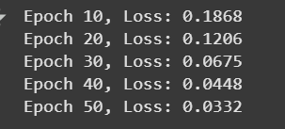

Results & Analysis
This time, the training loss dropped smoothly throughout the process, starting at 0.1868 by epoch 10 and reaching 0.0332 by epoch 50. That was a good sign, but more importantly, the model finally started to generalize. On the test set, I got a mean squared error of 0.283, an RMSE of 0.532, and an R-squared value of 0.703. That means the model is now able to explain more than 70 percent of the variance in product ratings, which is a huge step forward compared to the earlier version where the R-squared was negative.
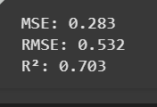
The predicted versus actual ratings plot backed that up. In my original version, predictions were mostly stuck around the average rating and didn’t follow the real values at all. But in the revised version, the points fall much closer to the diagonal red line, which represents perfect prediction. There’s still a little spread, especially in the lower rating range, but overall, the model is tracking the actual ratings across the full scale. The fact that it’s making smoother, more continuous predictions also makes sense since it’s a regression model trained on real-valued targets, even though most ratings in the dataset are whole numbers.
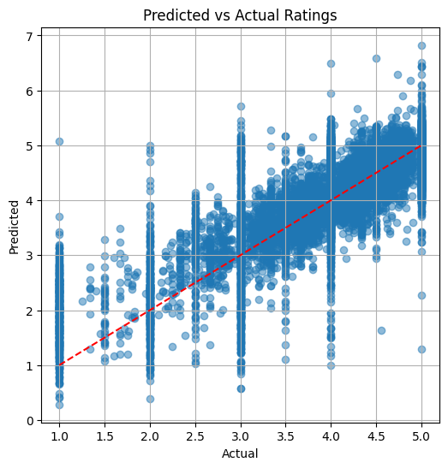
There were a few outliers, like predictions slightly above 5 or below 1. That happened because the model’s output layer is unbounded. If I were to go one step further, I’d probably try adding a sigmoid activation function and rescale it to match the 1 to 5 rating range. Still, the model is clearly picking up meaningful signal this time instead of just guessing the average.

Conclusion
This revised lab showed just how much of a difference data cleaning can make. After removing sparse and unreliable features and making sure everything that went into the model was clean and consistent, the neural network was finally able to learn something useful. The training went smoothly and the test set results were solid, especially that R-squared value of 0.703. It’s the strongest model I’ve built so far in terms of generalization. The biggest takeaway from this lab was that no model—no matter how complex—is going to work well if the data going in is messy. Deep learning models can be powerful, but they’re also sensitive to noise, multicollinearity, and imbalance. Moving forward, I’ll be more intentional about preprocessing and feature selection before jumping into training, especially when using neural networks.

